TBA-01

**Site** **Walk Sheet**

**/User Guide for Common Areas Add-in**

|  |
| --- |
| **Learning Objectives**   * Provide informative user documentation to onboard new users * Expose repetitive and common issues * Makes this add-in easier to use |

**Description**

This lecture will demonstrate the workflow for using the common areas add-in’s and discuss some common issues that the end-user might encounter while working on a daily basis.

Tailorbird integrates this tool into an overall BIM-workflow to facilitate the modeling of certain elements as well as execute some calculations. Thus, an outlook will be given on a current development project which aims to auto model Revit elements and calculate some meta data.

Table of Contents

1. Instalation 3

1.1. Folder path: 3

1.2 Installation procedure: 3

2. Getting started: FROM ZERO TO HERO IN UNDER 5 MINUTES 5

2.1 Description 5

2.2 Used files 6

2.3 Case study 1: 6

3. Common issues 8

3.1 Excel Exceptions (TBE-XX) 8

• TBE-01 8

• TBE-02: 9

3.2 Revit Exception (TBR-XX) 11

• TBR-01: 11

4. Conclusions and CHALLENGES 12

4.1 Conclusions 12

4.2 Challenges 12

# 1. Instalation

## 1.1. Folder path:

In order to download the application please visit the following [link](https://tailorbirdhomescom.sharepoint.com/:f:/r/sites/tailorbirdhomes-corporate/Shared%20Documents/Z_%20Latin%20American%20Misc/Work%20Guidelines%20-%20Base%20of%20Knowledge/Tailorbird%20Revit%20Plug-in/2.%20Common%20Areas%20-%20Revit%20Plugin?csf=1&web=1&e=MIX6sX):

## 1.2 Installation procedure:

Step 0: Uninstall previous version in case it’s not the first time you are installing the plugin.

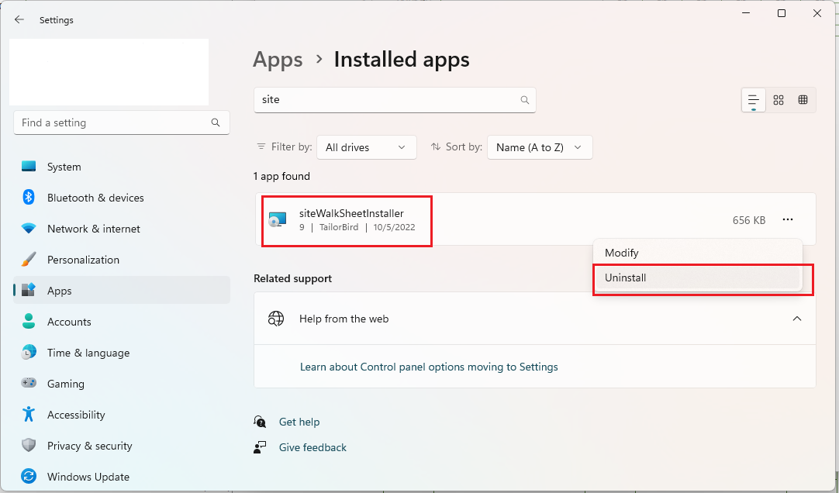

Step1: **Download both files** the .exe and .msi. Then, **run any of them to execute the installation**.

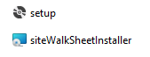

Step2: Open Revit 2023 and the following window will pop up. Confirm the loading process by hitting the “Always Load” button.

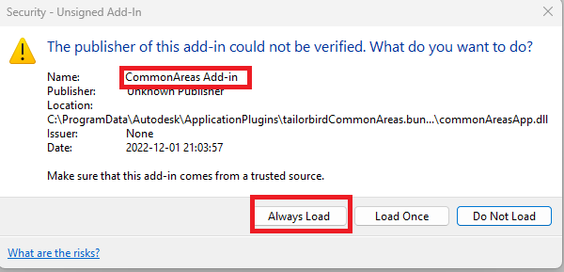

That’s it, you are all set up!

# 2. Getting started: FROM ZERO TO HERO IN UNDER 5 MINUTES

## 2.1 Description

Below is a list of commands available in the Common areas package and where they are briefly explained in this handout.

|  |  |  |
| --- | --- | --- |
|  | Command | Brief Description |
|  | Common areas Calculation |  |
|  |  |  |

## 2.2 Used files

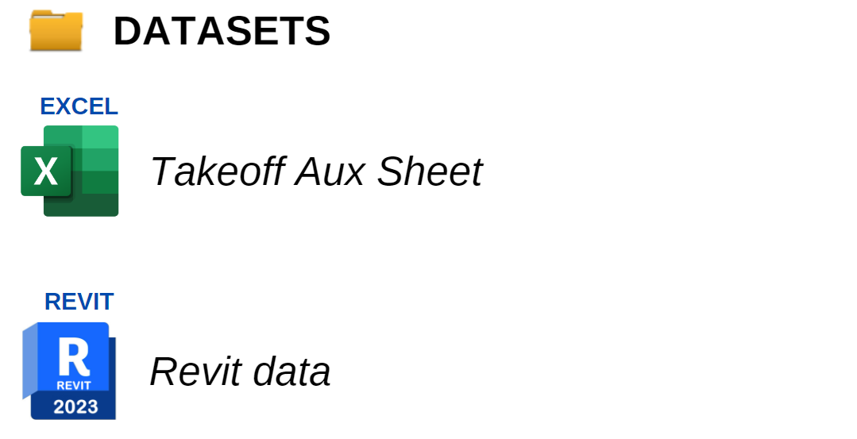

## 2.3 Case study 1:

In this quick exercise we will demonstrate how to use the most frequent tool to generate automatically a sitewalksheet.

Step 0: there exists a few prerequisites to run the plugin

* Set the current view as the walk sheet view.

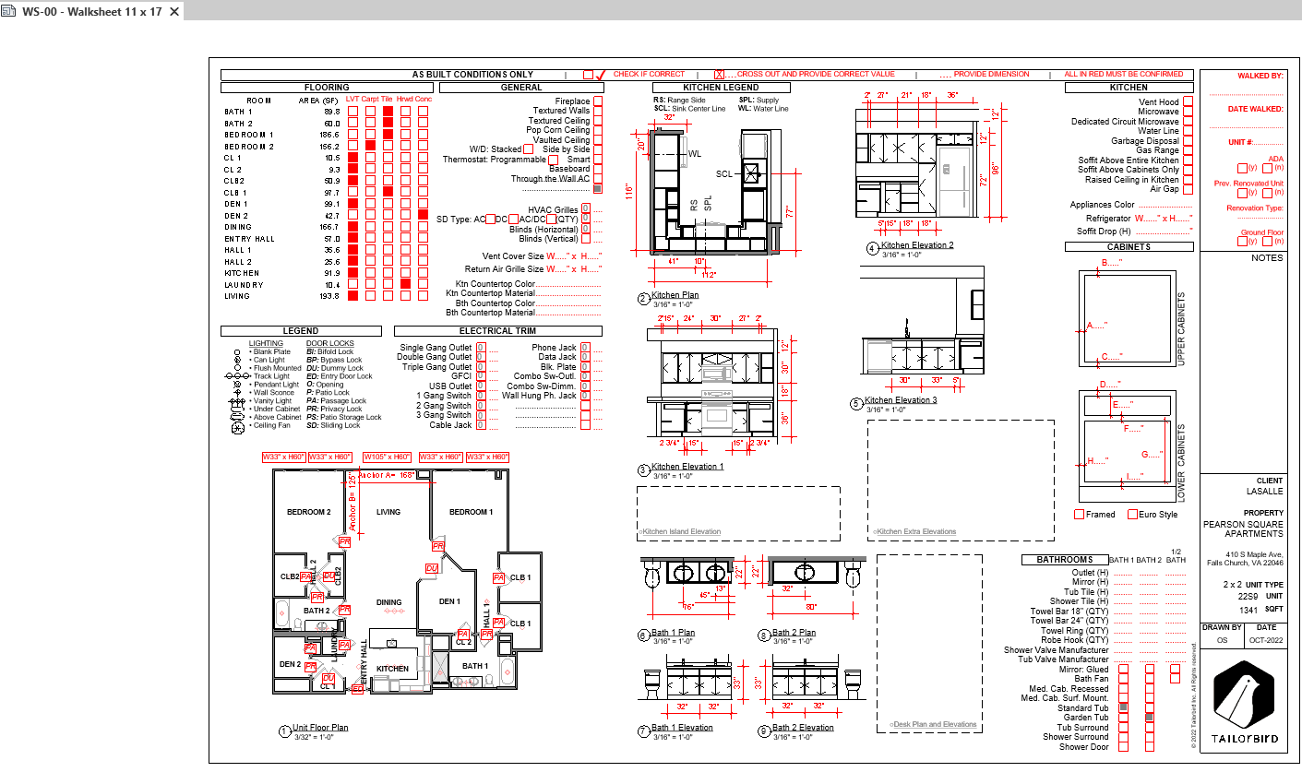

Step1: The first tool to apply is the “SiteWalkSheet”.

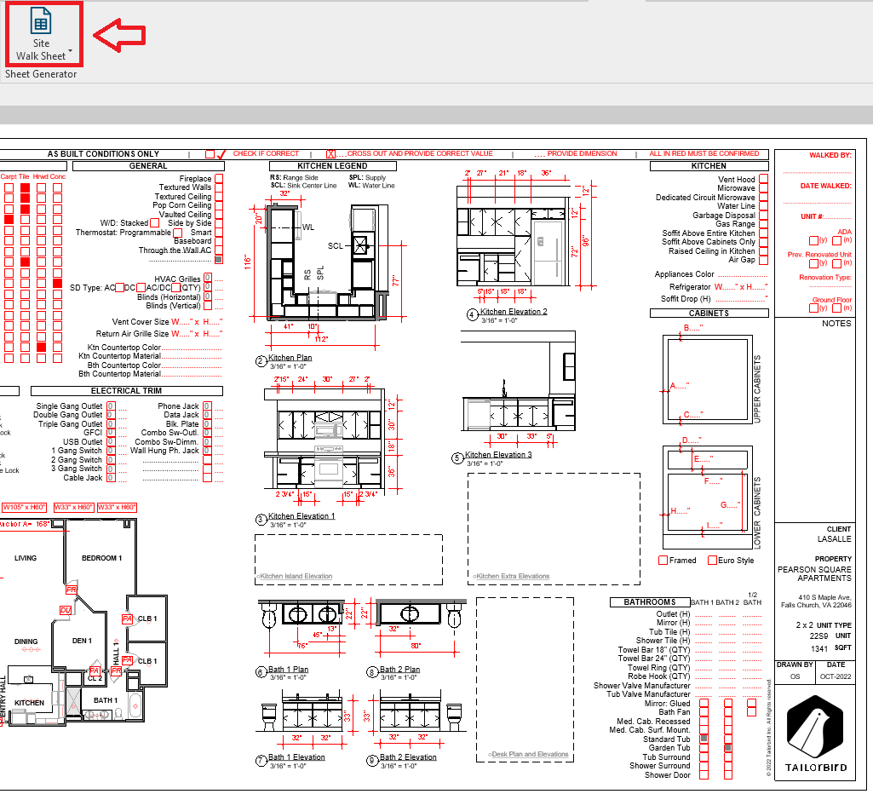

Step2: From here we can choose the excel sheet file that contain the information for the particular project unit.

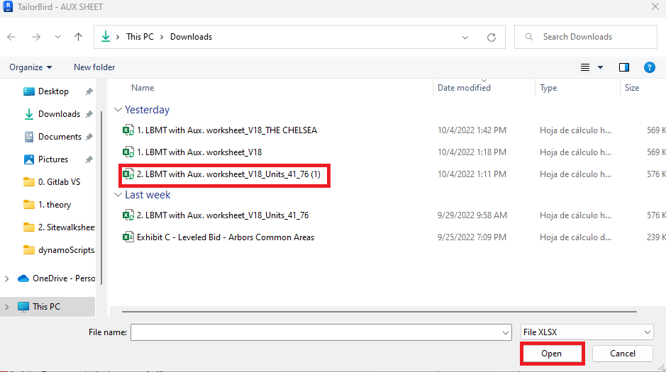

Once the excel sheet and Revit data have been populated in the site walk sheet parameters, it’s all done. That’s your 5 minutes up!

# 3. Common issues

The next few pages will cover some common issues encountered while using this application

## 3.1 Installer exception (TBi-XX)

* TBi-01: Project Number not Found in excel Sheet. Watch out for excel project numbers.
* *Solution*:

## 3.2 Revit Exception (TBR-XX)

* TBR-01: Revit encountered a Attempted to perform an unauthorized operation.

* *Solution*: This happens due to the program data file security, to fix that lets follow the next 3 steps:

1. Go to the following path:

# 4. Conclusions and CHALLENGES

## 4.1 Conclusions

Productivity improvement is the direct result of the process. This application also assures that the final results meet the same quality standards. Beside that, the BIM modelers involved in the workflow will no longer have to spend time placing the quantity takeoffs values from excel and Revit in the site walk sheet over again. Indeed, the extra time gained will let the team focus on singularities that require proper attention for building health.

## 4.2 Challenges

Revit API is a very stable open-source tool, but there are some issues or bugs that creates instability for production teams. Also, the way to debug in-house application errors could be a very painful and time-consuming task due to how Revit API commands are designed to work. Although, there is a good [documentation](https://www.revitapidocs.com/) and [forum](https://forums.autodesk.com/t5/revit-api-forum/bd-p/160) to ask topics about fixing or tracking errors, the lack of complete control of the tools could be a problem for further applications (Scan-to-Bim applications).

Transfer the tools from user to user is one of the main concerns that the developer team is facing at the moment because it turns complicated to monitor which version was installed in one’s PC, keep track of the updates of each individual and keep everyone updated. We are now aiming to deployed the [Updater command](https://learn.microsoft.com/en-us/dotnet/api/system.deployment.application.applicationdeployment.update?view=netframework-4.8) from Microsoft docs to start a synchronous download and installation of the latest version of this application.